JOBS DEVELOPMENT PARTNER PROGRAMME (JDPP)

**1 WHAT IS THE OBJECTIVE OF JDPP**

* JDPP is a government initiative through MTI and ESG, launched in April 2022 to help SMEs move into industry transformation and to push job redesign and job recreation
* The Programme is managed by SBF as the programme manager, and they partner the sectoral Trade Associations to work closely with their companies to enhance the joint effort of this programme, to help kickstart businesses in their transformation journey

**2 HOW JDPP WORKS**

* It’s a **complimentary holistic advisory service** provided by an **Industry Transformation Advisor (ITA)**
* For SME’s who sign-up for participation in this transformation journey, our ITA will partner you and assist you with the following:
  + Review your existing landscape and transformation readiness
  + identify company needs and gaps
  + recommend solutions
  + connect you with the solution providers and government grants
  + Provide project management support
  + Review skills transformation of your manpower to support your business transformation

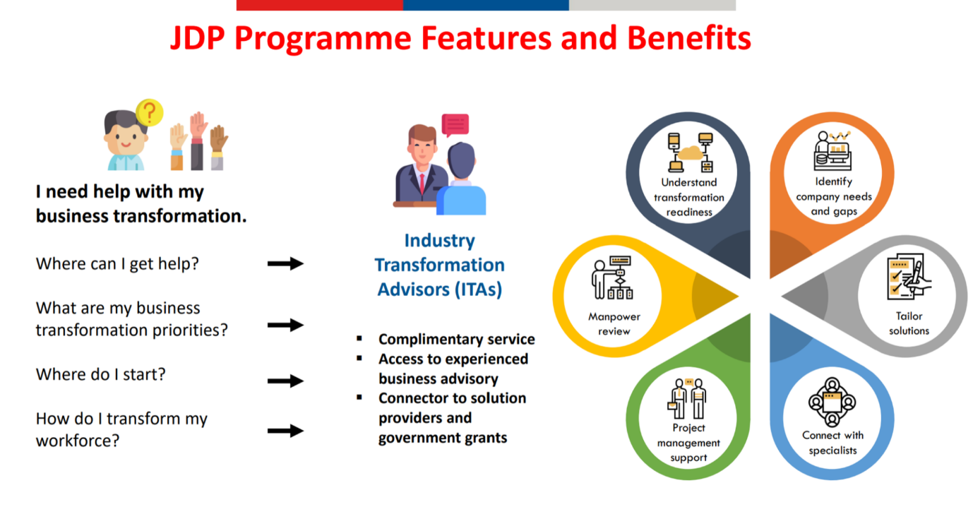

**3** WMRAS is proud to partner Singapore Business Federation (SBF), to bring you the Jobs Development Partner Programme (JDPP).

We encourage our companies to build a strong and resilient local talent base in the new norm, through acceleration in industry transformation, leveraging on job creation and job redesign, upskilling and reskilling of workers. To see this through, we urge our companies to come on board the JDP Programme by filling up the participation form, below

**4** FOR FURTHER INFORMATION, PLEASE CONTACT:

|  |  |
| --- | --- |
| **Mr JJ Simon, PBS, PB**    **Senior Industry Transformation Advisor, WMRAS**  Email: [jonahjoshuas@wmras.org.sg](mailto:jonahjoshuas@wmras.org.sg)  Mobile: 93875091 | **Profile of WMRAS’ Senior ITA**  **Retired** from public service, after serving more than 47 years in ENV and NEA. Was the regulator of the waste management industry for more than 20 years.   * Advanced Certificate in Training Assessment (ACTA) * Chaired the Singapore Standards (SS) Working Group for developing SS EN 840 Standard, 2014 * Member of the Working Group for the SS 369, 2014 * Member of the Working Group for the SS EN 1501 Standard, 2016 * Member of the Working Group for the SS 649, 2019 * Working member of DIN ISO/TC 297 Technical Committee, Waste Management Secretariat, 2018 * Singapore Accreditation Council (SAC) – Appointed as a Technical Assessor under the SAC [Inspection Body] Scheme, * Certified Home Team Academy (HTA) as an Investigator * Certified bizSAFE Level 2 (Risk Management Audit) * Singapore Accreditation Council (SAC) – Gold Award (2021) |

Participation Form



18 Jan 2023